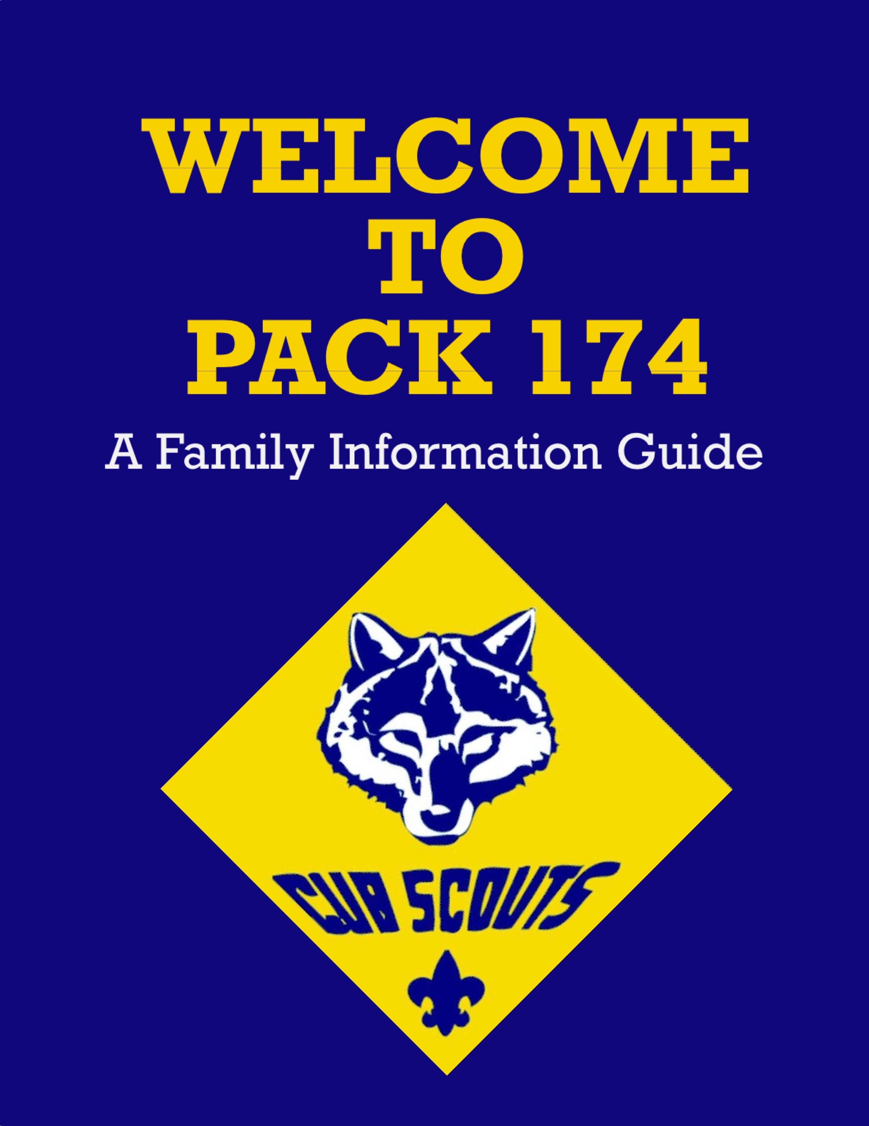
Cub Scout Pack 510 is a member of the Boy Scouts of America now called Scouts BSA and the Middle Tennessee Council, Cogioba District.
Pack 510 is proudly Chartered by American Legion
CSM Gary W. Crisp Post 289 in Clarksville, Tennessee 37042
510

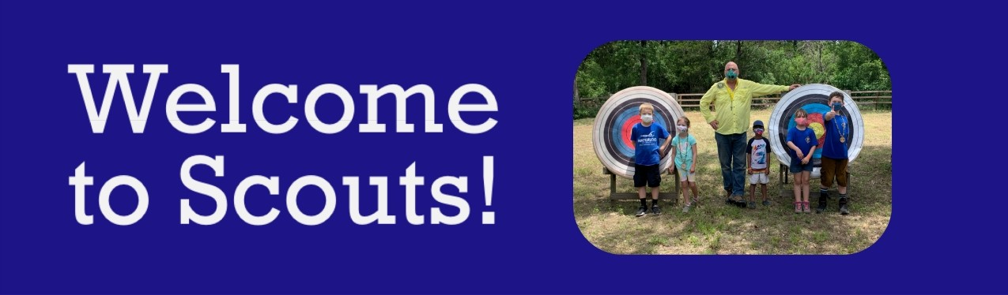

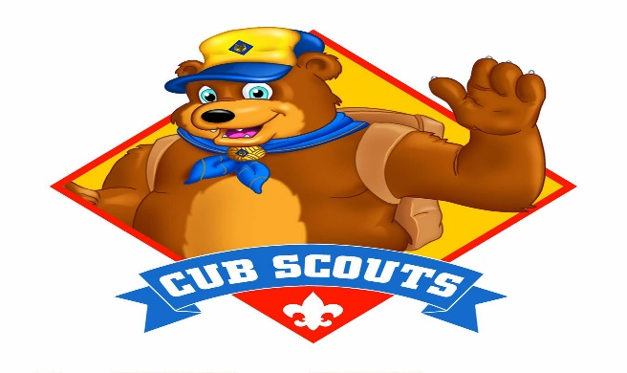

Scouting is more than just an activity. It's ADVENTURE, learning, discovery around every corner. From STEM to exploring the outdoors, yow child will be on the path to discovering their very best “future self”- and they will have FUN doing it!

YOUR CHILD IS A MEMBER OF A DEN WHICH:
- Has three to nine members (single gender per den)
- Meets 1-2 times per month in den meetings
^ Is led by a Den Leader (usually a parent of a scout in the den)
^ At the meetings, does activities like games, sports, crafts, hands on

learning and field trips!
YOUR CHILD IS A MEMBER OF A PACK WHICH:
- Is made up of all grade level dens
- Meets once a month at Pack Meeting
- Is led by Cubmaster _______________
- Follows a theme with games, skits, songs, ceremonies and presentations of earned awards
OUR PACK IS RUN BY THE COMMITTEE WHICH:
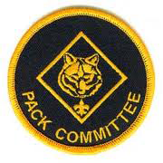
- Is made up of volunteer leaders and parents
- Meets once a month or as needed (Usually 3rd Thursday of Month)
- Is led by the Committee Chair
*The committee finds meeting places, preforms record keeping, manages announcements and advancements, maintains pack equipment, helps train leaders, recognizes leaders and plans activities

Page 1- Welcome

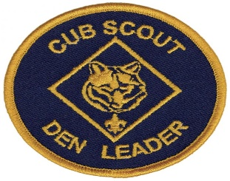



Lion- Kindergarten
Lions experience the Scouting concepts of character development, leadership, citizenship
and personal fitness through engaging and exciting adventures with their den and family.


Tiger- First Grade
Tigers earn their badges by completing six required adventures with their den or
family, one additional elective adventure of your den or family's choosing and projects in the Youth Protection Parent Guide. They will be introduced to hiking, hike safety, healthy snacks and the Cub Scout 6 Essentials.

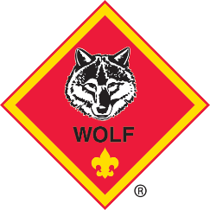
Wolf- Second Grade
Wolves earn their badges by completing six required adventures with their den or family, one additional elective adventure of your den or family's choosing and projects in the Youth Protection Parent Guide. They will be introduced to the Outdoor Code of Ethics, flag etiquette, different ways to communicate and team building.

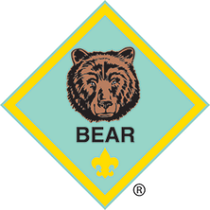
Bear- Third Grade
Bears earn their badges by completing six required adventures with their den or family, one additional elective adventure of your den or family's choosing and projects in the Youth Protection Parent Guide. They will be introduced to the whittling, hand tools, campsite setup, animal knowledge and family safety.


WEBELOS & Arrow of Light- Fourth/Fifth Grade
When a Cub Scout graduates to Webelos, they have the opportunity to earn the highest award in Cut Scouting, The Arrow of Light. In addition to five required adventures, they will complete two elective adventures and projects in the Youth Protection Parent Guide. Webelos can participate in additional camping and outdoor programs until graduating to a Scouts BSA Troop in the spring of their fifth-grade year.


Serving Today's Family through “Family Scouting”
The BSA's mission is to prepare young people to make ethical and moral
choices over their lifetimes by instilling in them the values of the Scout Oath and Scout Law. We are excited to announce that our Cut Scouting program is open to boys and girls! By welcoming both boys and girls into the program, even more youth will have access to the character development and values- based leadership that Scouting promises!

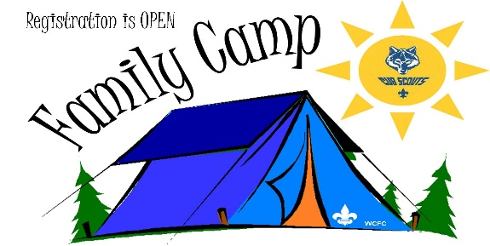

CAMPING
We go camping to at least twice a year as a whole pack. The first campout
happens around Halloween. During this campout we have a tent decorating and costume contest, complete with trophies. The second campout happens in the late spring.

PINEWOOD DERBY
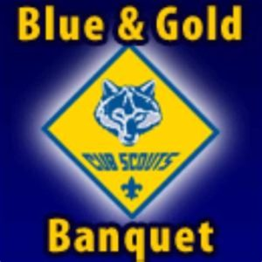
Our Pinewood Derby happens mid-spring and is quite the event! Scouts get a free car to build when they register. Scouts have the opportunity to win a Den trophy and an overall Pack trophy. We also have “beauty” contests with different categories scouts can vote for each year.

BLUE AND GOLD
A celebration of our Arrow of Lights who are graduating to a Troop. This is also the National “Birthday” Celebration of Cub Scouting.

MORE (BUT NOT ALL) SAFE, FUN AGTIVITIES
Pack Hikes: We have lots of local trails we like to explore and learn together.

Bike Ride Abounds: We meet at our local elementary school and have a fun time learning bike safety, etiquette and practicing biking skills.

Service Projects: Helping our communities is a major part of Scouting. We have multiple service projects throughout the year. Service projects are a requirement of the Scouting program.

Local/State Events: There are a few times during the year the districts and councils come together to celebrate scouting.
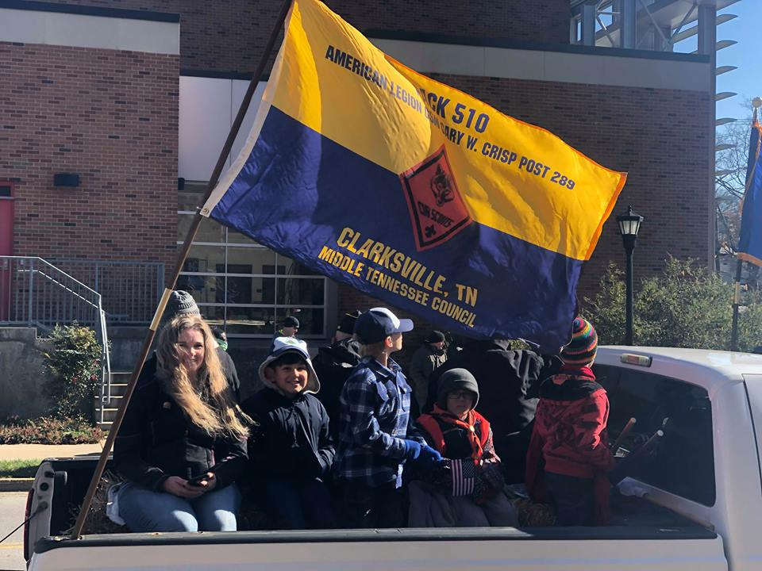

SUMMER TIME

Each summer Scouts can earn a Summer Time Award Pin for
attending at least 1 scout activity each month; June, July, August. These activities can range from Scout Day Camps, Parades, Splash Pad Dates, Sports Night, Local Community Events on our Pack Calendar and more!

Pack 510 at Welcome Home Veterans Day Parade

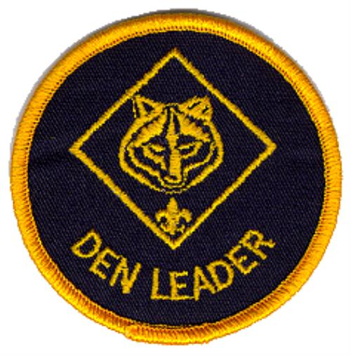
Scouting operates through volunteer Membership. Naturally, parents are the source of members in the Scouting Program. the require air of our parents to volunteer with helping with at least one peck scouting event. We view our peck as a large scouting family and it takes all hands-on deck to create the total scouting experience.

Training for Volunteers
Training is a vital role of learning how to become an effective leader. The
main purpose of training is to provide you with the tools you need to put on a quality program for our scouts. Scouting offers most of its training online.
Youth Protection Training
The Boy Scouts of America places the greatest importance on creating the
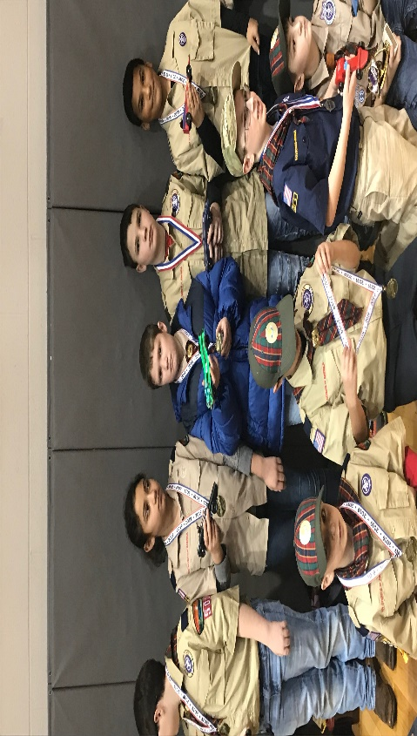
most secure environment possible for our scouts. Our pack requires this training for every parent. This training covers the BSA's YP policies, kinds of abuse, how to respond to disclosures of abuse, and proper reporting procedures. This training lasts two years and is completely done online. You must have your YP training prior to contact with the Scouts.

Leadership Roles
The Boys Scouts of America takes great pride in the quality of our adult
leadership. Being a BSA Leader is a privilege, not a right. The BSA's rigorous volunteer application and screening progress includes local selection and screening as well as a national criminal background checks.

Cubmaster Helps plan and carry out pack programs with the assistance from the pack committee. Emcees the monthly pack meeting and helps plan activities.
Committee Members preform administrative functions and planning the
activities for the year.
Den Leader Leads the den at monthly den and pack meetings Assistant Everyone needs an assistant from time to time.
Volunteer Opportunities
Throughout the year many different opportunists will be available for you to help OUI
pack be at its very best. This can range from helping organize service project to events, planning food and activities for parties, or assisting leaders with den specific needs.

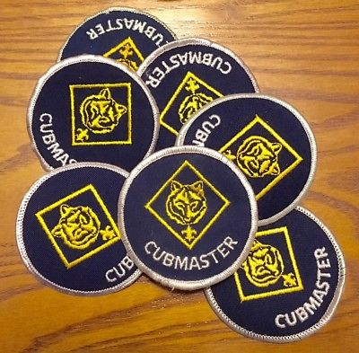

First Things First...
Contrary to what your Scout may tell you, the first thing they will need to get
started is not a uniform, but a book. The books in Cub Scouting are for all ages appropriate. Each level has a packet or book they will use to help them stay organized and on track. These books can be purchased at the local scout shop.

Clarksville Scout Shop
1860 Wilma Rudolph Boulevard, Suite 110 C
Clarksville, TN 37040
(Located inside Leap Plaza - park in the back and enter) Phone:(931) 230-0930
​Regular HOURS:
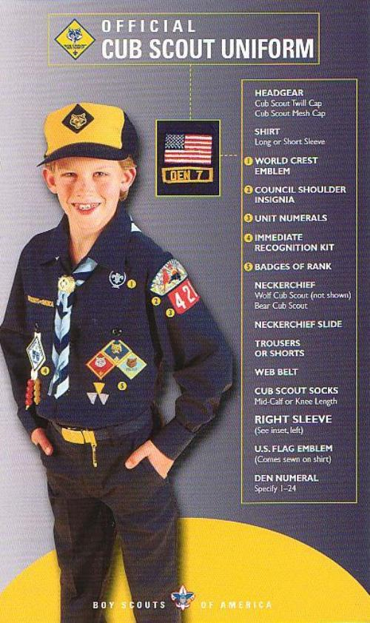
Monday, Wednesday and Friday
1:00 p.m. - 5:00 p.m.
Saturday 10 a.m. – 2:00 p.m.
Tuesday, Thursday and Sunday CLOSED

Cub Scout Uniform
Don't get the idea that uniforms aren't important, they are! The uniform is an
important part of the program, and it represents an investment on your part. Our uniforms are high quality and, in most cases, last several years. So, be sure to buy a size or two bigger to account for scout growth. Lion uniforms are a Lion Shirt and hat. The rest of the scout uniforms consist of a shirt with pack numbers, belt, neckerchiefs, neck slide, hat and shorts/pants/skort. All of these items can be purchased at the local scout shop.
Class B Shirts
For many of our scouting events we wear a more casual outfit. The Class B shirts can be bought from our Committee Chair. We have youth and adult shirts, as well as regular cotton and moisture nicking materials.

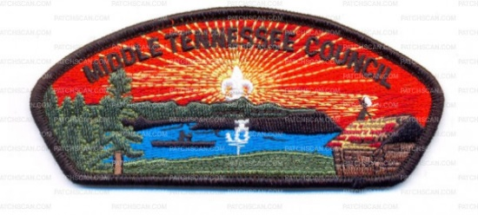

The Cost of Scouting

The most important thing:
We will NEVER turn away a child because of their family's inability to pay for part of
the cost of scouting. We have a scholarship program available; if receiving a scholarship can make a difference for your child being able to participate, please get in touch.

Registration
If you are brand new to scouting, you'll pay the Registration Fee when you create your New
Scout Application on my.scouting.org. The cost will be:
- new member + -$25 Plus $76.00 registration fee + $2.00 Insurance admin Fee
- Optional: Scout's Life magazine $12.00 annual fee
Pack Dues
All scouts in Pack 510 pay $50.00/ year in pack dues — including those scouts who are brand
new to the pack. Dues must be paid in full before October 31. This covers the cost of our Scouting program, which includes local council fees and the National BSA Organization, pins, loops, ribbons, and some camping costs. The scout year runs from August to June, with a few additional activities taking place over the summer.

Pack Adult Leaders Registration
Yes, all Pack Adults who are helping us as Den Leaders or Committee Members must be a Registered leader and must be certified first by completing the free on-line Youth Protection training before having contact with the youth Membership. They also must have a back ground Check.
Leader fees are $46.00 Plus $2.00 Insurance.


Fundraising
We try to stay out of parents' pockets as much as possible, and encourage Scouts to participate in our annual fundraiser to help support the cost of scouting. We put a lot of effort into the Trails End Popcorn Fundraiser each August-October. Scouts can sell popcorn by participating in in-person sales in front of store fronts, selling to family/friends or doing online sales, which gets shipped directly to the buyers front door. Scouts can earn prizes not only from Trails End, but from our Pack as well for selling the most popcorn!



Have More Questions?
We hope this packet of information has been helpful, but if you need more information,
please get in touch.
Membership Chair: Committee Chair: ______________________ Cubmaster: __________________________

Communication

Pack Website Scoutlander
Once you are officially registered you can sign up for a login/password to our Pack 510
Website Scoutlander. This contains our calendar, pack rosters, emails and loads of good information.

Facebook
Please don't forget to follow us on social media at Cub› Scouts Pack 510 Clarksville

Scout book
You will need to make an account to monitor your scouts progress and RSVP to any

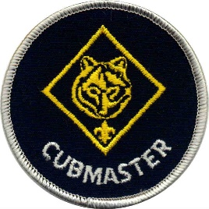
Cubmaster Welcome

We are so excited to have you become a part of our scouting family! Please don't hesitate to reach out and ask any questions, as this process can be a tad overwhelming. We want to make it as easy as possible for you and your scout to start having fun and creating new memories.

Welcome to Cub Scout Pack 510
at Barkers Mill Elementary School.
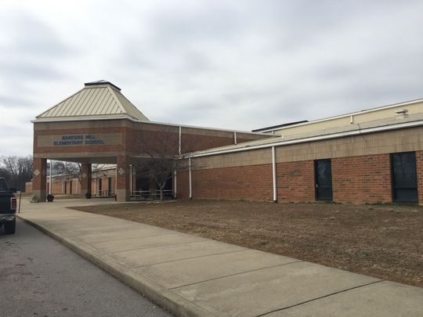

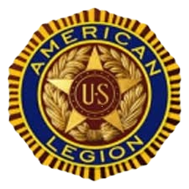
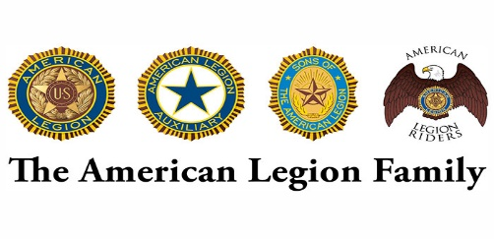
Who is our Chartering Organization?
The American Legion's support for Boy Scouts of America began at the Legion’s first national convention in 1919. Today, Legion posts sponsor more than 2,500 Scouting units across the country. This is natural for Legionnaires, who bring their service-learned skills and experiences as veterans to help build character and positive traits in our country’s youth. Few other post activities generate more goodwill from the community.
The American Legion annually honors the Eagle Scout of the Year at the national convention. The winner of the competition receives a $10,000 scholarship, and the three runners-up are each awarded $3,500 scholarships.

Post 289 received our temporary charter as American Legion Fort Campbell Post 289 in February 2016. Since 2017, when the post was permanently chartered and renamed to memorialize CSM Gary W. Crisp. The post meetings are held every third (3rd) Tuesday at Sykes Funeral Home, 424 Franklin St, Clarksville, TN. The membership starts at 6:00PM. American Legion CSM Gary W. Crisp Post 289 strives to support area veterans and communities by supporting the 4 pillars of Veterans Assistance and Rehabilitation, National Security, Americanism, and Children and Youth. Our success depends entirely on active membership, participation and volunteerism. The organization belongs to the people it serves and the communities in which it thrives.
Please accept this invitation to meet with other Post members, Veterans, and get involved locally.
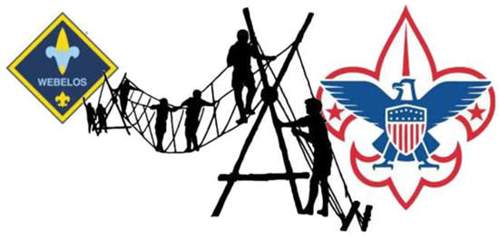
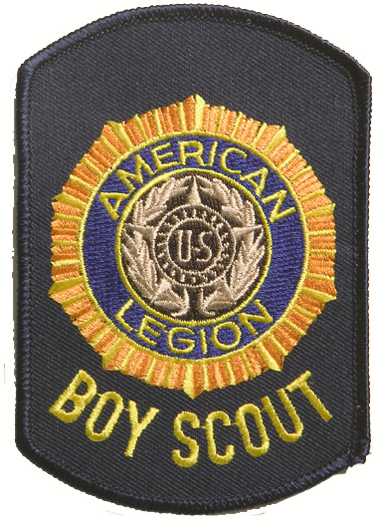
Follow us on Facebook
https://www.facebook.com/AmericanLegion289​
Mailing Address
P.O. Box 2641
Clarksville, TN 37042
Post Officers Contact Numbers and Email Addresses
Commander – David Zeveney 931-338-7612
TNPOST289.COMMANDER@GMAIL.COM
Adjutant – Bob Grigsby 614-208-2154
AmericanLegion.Post289Adjutant@gmail.com
Finance Officer – Larry Johnson 931-257-8069
Americanlegionpost289.finance@gmail.com
1st Vice – Tony Saluzzo 931-431-3841
Tony.Saluzzo289@gmail.com
2nd Vice – Ernest Schmidt 931-624-8564
Eaglewarr7@yahoo.com
Sergeant at Arms – Bob Sisson 931-919-3712
bob@sissonmail.com
Chaplain – Anthony Carmona
tony.carmona@kofc.org​
Service Officer – John Beck 817-301-9223
Jmbeck5729@sbcglobal.net
Post Scouting Program Chairman - Douglas Kirby 931-801-1415​
rotebard@yahoo.com
Judge Advocate – J.D. McFarland (931)302-7410
soaringeagle7410@gmail.com
Our Cub Scout Pack is a Member of the American Legion Department of Tennessee Scouting Program

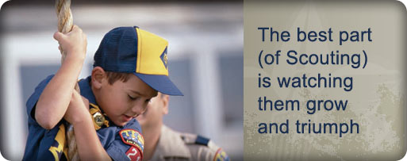
The Chain of Command
Yes, the Pack has a chain of Command, you should try and adhere to it as much as possible.
At no time will a unit leader or Parent be allowed to jump this chain of command and go to the Middle Tennessee Council or District without first trying to resolve the problem within the Pack first.
If the Pack Cub Master and or Committee Chairperson cannot resolve the issue then the Charter Organizational Representative will intervene. They are known as the Post Scouting Chairman
The pack is owned by a Chartering Organization
• The Chartered organization for Pack 510 is American Legion CSM Gary W. Crisp Post 289 in Clarksville.
• The chartered organization approves leaders, provides a meeting place, and operates the pack within the guidelines and policies of the chartered organization and the Boy Scouts of America.
• The chartered organization selects a Chartered Organization Representative who serves as a liaison between the pack and the organization. The Chartered Organization appoints and approves of the adult leadership group that leads the pack.

Chartered Organization Representative:
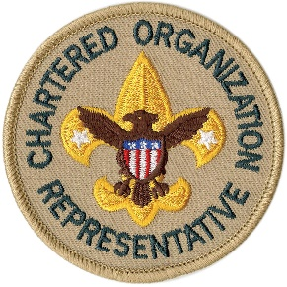
- The chartered organization representative’s primary responsibilities are to help units to be successful and to provide coordination between the chartered organization and Scouting.
- The chartered organization representative is automatically a voting member of the council and the Pack Committee.
- The COR can remove anyone from their position without cause.
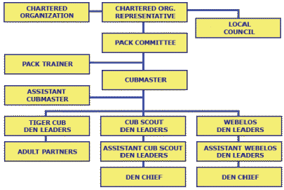

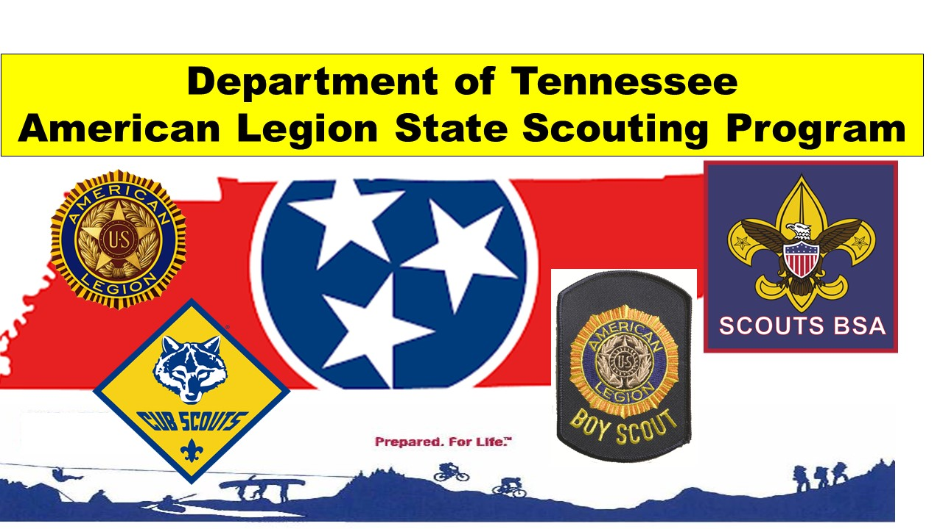
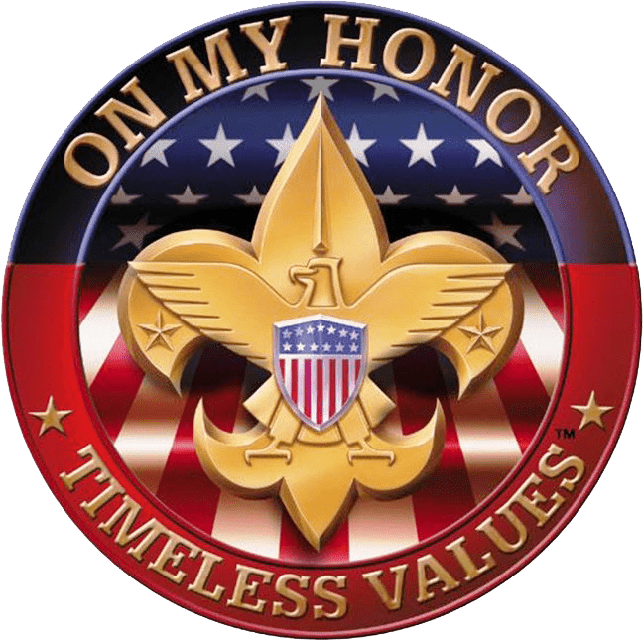
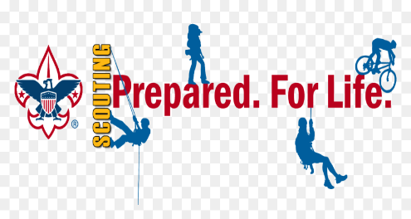
Yes, we also have Boy Scouts = Scouts BSA Troops
What are the requirements to be a Scout?
- Meet age requirements: Be a boy or Girl who is 11 years old or one who has completed the fifth grade or earned the Arrow of Light Award and is at least ...
- Complete a Boy Scout application and health history signed by your parent or guardian.
- Find a Boy or Girls Scout troop near your home.
- Repeat the Pledge of Allegiance.
- Demonstrate the Scout sign, salute, and handshake.
- Demonstrate tying the square knot (a joining knot).
- Understand and agree to live by the Scout Oath or Promise, Scout Law, motto, and slogan, and the Outdoor Code

You can go to this web site and join on line: https://beascout.scouting.org/

If you have a son or a daughter who is interested in Scouting and meets the above requirements, please see our Post Scouting Chairman Red Kirby we already have 3 active Scout Troop within Clarksville. It depends mostly on where you live at.

Please see our Facebook page also.

